|  |  |  |  |  |  |  |  |
| --- | --- | --- | --- | --- | --- | --- | --- |
| !pip install pillow   |  |  | | --- | --- | | Requirement already satisfied: pillow i | n | | /usr/local/lib/python3.11/dist-packages (11.1.0) | |   from google.colab import files  *# Upload the file* uploaded = files.upload()   |  |  | | --- | --- | | <IPython.core.display.HTML object> | | | Saving input.jpg to input (2).jpg |   input_image = "input.jpg" *# Replace with your uploaded image file name*  encrypted_image = "encrypted.jpg" *# Path to save the encrypted image* decrypted_image = "decrypted.jpg" *# Path to save the decrypted image* from PIL import Image  *# Encryption Function* def encrypt_image(input_path, output_path): img = Image.open(input_path) pixels = img.load() width, height = img.size  for i in range(width): for j in range(height): r, g, b = pixels[i, j]  *# Swap Red and Blue channels*  encrypted_pixel = (b, g, r) pixels[i, j] = encrypted_pixel  img.save(output_path)  print(f"Image encrypted successfully! Saved as: {output_path}")  *# Decryption Function with Color Change* def decrypt_image_with_color_change(input_path, output_path): img = Image.open(input_path) pixels = img.load() width, height = img.size  for i in range(width): for j in range(height): r, g, b = pixels[i, j]  *# Swap back Blue and Red*  original_pixel = (b, g, r) |

|  |  |  |
| --- | --- | --- |
| *# Apply a color transformation (e.g., increase red by 50, cap at 255)*  new_r = min(original_pixel[0] + 50, 255) *# Increase red*  new_g = max(original_pixel[1] - 30, 0) *# Decrease green*  new_b = original_pixel[2] *# Keep blue unchanged*  pixels[i, j] = (new_r, new_g, new_b)  img.save(output_path) print(f"Image decrypted with color change! Saved as:  {output_path}")  encrypt_image(input_image, encrypted_image)   |  | | --- | | Image encrypted successfully! Saved as: encrypted.jpg |   decrypt_image_with_color_change(encrypted_image, decrypted_image)   |  | | --- | | Image decrypted with color change! Saved as: decrypted.jpg |   from IPython.display import display  *# Display Original Image* print("Original Image:") display(Image.open(input_image))  *# Display Encrypted Image* print("Encrypted Image:")  display(Image.open(encrypted_image))  *# Display Decrypted Image with Color Change* print("Decrypted Image with Color Change:") display(Image.open(decrypted_image)) Original Image: |

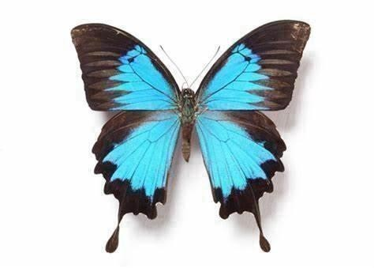

Encrypted Image:

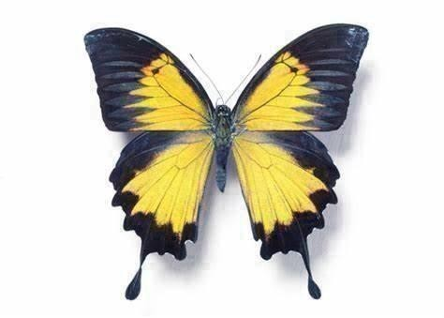

Decrypted Image with Color Change:

